Background

The design of the radar system is driven by existing components. The components that are the most expensive and time consuming are the waveform generator and data acquisition systems. These were built over the past few years at KU and have proven very reliable. They are as follows.

Waveform creation:
- Dual Channel 16-bit 160 MSPS Arbitrary Waveform Generator Card
- Single Channel 10-bit 1 GSPS Direct Digital Synthesizer Card

Data Acquisition:
- Dual Channel 12-bit 160 MSPS Data Acquisition Card
- Single Channel 9-bit 720 MSPS Data Acquisition Card

The high speed data acquisition card is shown below.

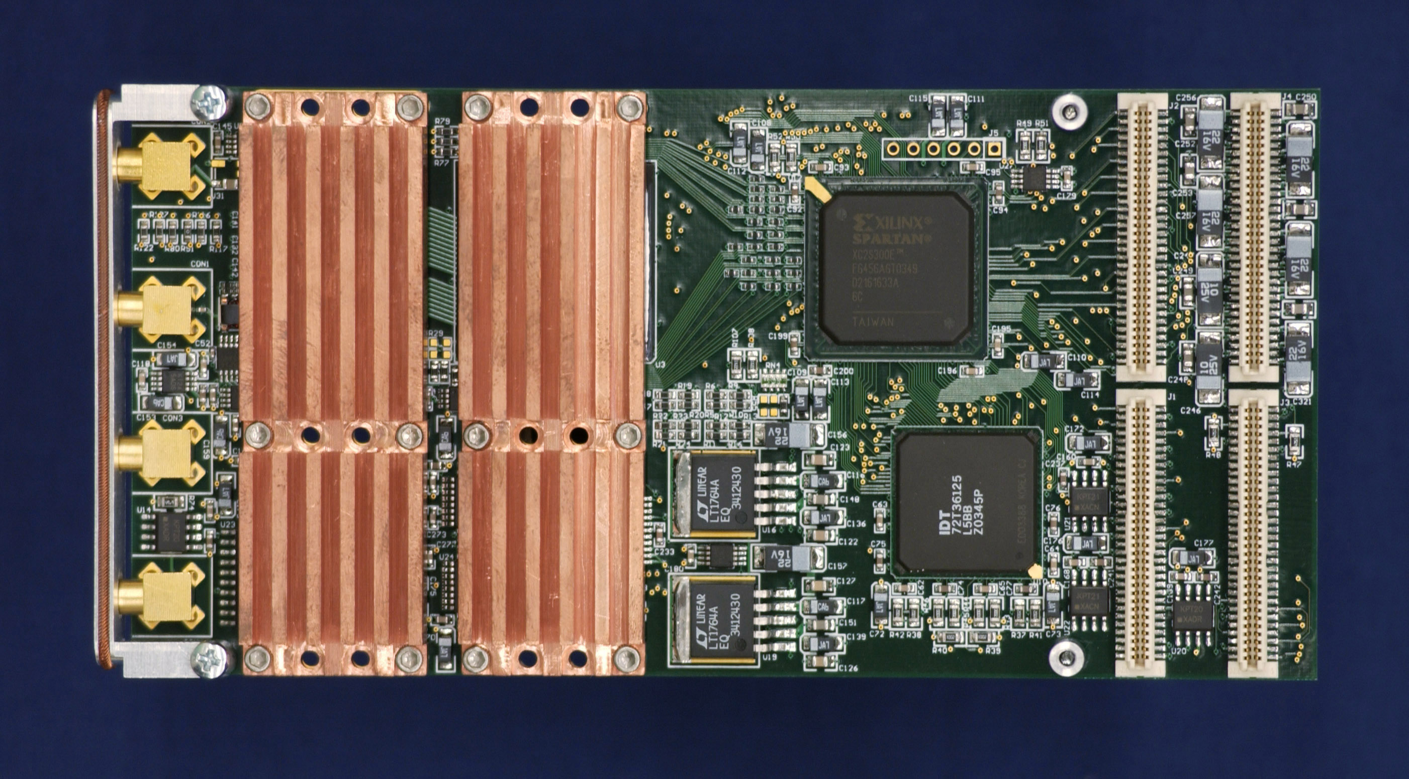

All the cards are of the same form factors. These cards are plugged onto carrier cards which are then plugged into a compact PCI slot. Each carrier card can hold two plug on cards. Different combinations of plug-on cards can be placed on multiple carrier cards to make up the desired data system. Two high speed data acquisition cards placed on the same carrier card is not allowed due to thermal and power issues.
System Design 1

This is the radar system that was proposed initially. We have expanded the number of channels from 6 to 8. There would be 8 receivers and 8 data acquisition channels. It would have two bands: 140-160MHz and 425MHz-475MHz. By moving the sampling rate from 130 MHz to 120 MHz we would be able to directly sample both of those bands. This eliminates the need to distribute LO signals to the multiple receivers.

The data rate for this system would be as follows:

Total Data Rate = 8 * Data Rate Per Channel;
Data Rate Per Channel = Data Window Size * Sampling Rate * 2 bytes per sample * (PRF / Number of Presums);

Total data rate cannot exceed 20 Mbytes per second. With the sampling rate fixed at 120 MHz, the parameters that can be adjusted are the data window size, PRF, and number of presums.

If the data window size is 40 us and the number of presums is 16, the max PRF will be 4167 Hz.

This is the preferred design. It is similar to other designs that are under development. This system can be completed for the Fall 06 experiment.

System Design 2

If more than 50 MHz bandwidth is required for the upper band. We would have to use the high speed data acquisition cards. Due to the number of carrier cards required, the number of data acquisition channel would have to be reduced. We would still sample the eight antenna elements, but they would be multiplexed into 2 receivers. This reduces the effect PRF due to the fact that we cycle through the antenna elements. For example, if we use a 4000 Hz PRF, the effective PRF would be 1000 Hz. We would be transmitting every 250 us, but it would be 1 ms before we sampled four elements. Since we would have two receivers, this translates to 8 elements in 1 ms.

The data rate for this system would be as follows:

Total Data Rate = 2 * Data Rate Per Channel;
Data Rate Per Channel = Data Window Size * Sampling Rate * 2 bytes per sample * (Transmit PRF / Number of Presums);

Total data rate cannot exceed 20 Mbytes per second. With the sampling rate at 250 MHz, the parameters that can be adjusted are the data window size, PRF, and number of presums.

If the data window size is 40 us and the number of presumes is 4, the max PRF will be 2000 Hz. This will result in an effective PRF of 500 Hz.

While this design allows for greater bandwidth, it is at the expense of SNR. The higher sample rates force us to reduce the PRF and the antenna element multiplexing reduces the number of presums we can do.

