GISMO Data Review: Range Compressed Data

Report Prepared by:

K. Jezek and X. Wu

November 14-15, 2007
Boulder, Co.

Table of Contents
1.0 Introduction 2
2.0 September 8: 450 MHz; GISMO Mode; Ice Stream Line; High Elevation 3
3.0 September 10: 450 MHz; Depth Sounder; Ice Stream Line; Low Elevation 4
4.0 September 11: 150 MHz; GISMO; High Elevation; Ice Stream 6
5.0 September 12: 150 MHZ GISMO outbound, CARDS inbound; Low Elevation; Ice Stream 7
6.0 September 14: GISMO; 150 MHz; High outbound; Low altitude Inbound; Jacobshavn and Coast 9
7.0 September 15: 450 MHz; Outbound High, Inbound Low; GISMO; Jacobshavn and Coast 10
8.0 Selected Data Sets 10
8.1 Thin Ice Case, Low Elevation Only, 150 vs. 450 MHz comparison 10
8.2 Ice Stream Case 12
8.3 150 MHz clutter rejection case 13
9.0 Near Term Science and Technical Objectives 14
10.0 References 15

1.0 Introduction
We examined all range compressed, intensity modulated GISMO data collected between September 8 and September 15. Only a small sample of September 7th data was inspected because the data were not yet completely processed at the time of the review. No data were inspected for September 18. Both the 7th and the 18th data sets will be analyzed later. Because the September 7th data may be contaminated by accelerometer noise and the data form the 18th are only at high altitude, we concluded earlier that September 8 to 15 data are likely to be the most useful for our near term studies. That point noted, a vast amount of data was inspected, annotations were compiled, and a processing strategy developed.

We viewed each radar data file separately and occasionally composited up to 10 files into longer strips. The processed data consisted of a single channel for which all 2500 lines were displayed. We commented on each file and prepared a summary narrative and a summary table for each flight. These are presented in sections 2 through 7.

We listed several criteria for selecting individual files for near term processing. These were;

1. Identify 150 MHz low-altitude frames having the strongest, longest echo.
2. Identify the corresponding high-altitude frames
3. Repeat 1 and 2 for the 450 MHz. The selected 150 and 450 MHz frames selected based on (1) and (2) may or may not turn out to be co-located.
4. Compare 450 and 150 MHz high and low elevation data at the same location.

Based on these criteria, we identified key near term data sets that merit additional processing (section 8). These data will be processed to range and azimuth compressed image files and delivered to the team.

Our general observation is that high elevation data are almost uniformly poor. This is partly due to clutter that obscures the echo and partly due to the low amplitude of the basal return in some locations. We concluded that any future high altitude experiments will substantially require higher power and more directional antennas. In addition, we need to review the rationale for receiver attenuator settings.

As documented in the field report (Jezek and others, 2007), we observed that the accelerometers emitted a strong noise signal that corrupted the 150 MHz radar data. We recognized the problem early on September 8 and so the accelerometers were on only briefly for testing purposes. Consequently the bulk of the September 8 data are accelerometer-noise-free. Initial inspection of some of the data from September 7 did not obviously display the same interference signal observed on the 8th, even though the accelerometers were on for the entire flight. If this observation is confirmed, it might suggest that the accelerometers became a noise source sometime between the 7th and 8th.

We made observations to test whether laser noise contaminated the data during the flights. Our conclusion in the field was that shielding and physical separation between the laser and the antennas reduced laser noise to the thermal noise level of the receivers. Unfortunately, subsequent analysis does not support our initial conclusion. This means that either an effective shielding method must be developed for the future, or, the radar must be the sole instrument operating on all flights requiring maximum signal sensitivity.

We performed a few simple experiments to test other properties of the data. We compared signal levels for the same location recorded using both 3 and 10 us pulses. We observed that the 10 us pulse was a few dB stronger than the 3 us pulse. We also looked at signal to background levels for high and low elevation flights. The observation seems to bear out the conclusion that clutter contaminates the signal. The alternative hypothesis, that the signal levels are low and that the increase elevation simply pushed the signal into the receiver thermal noise, may be a factor in some locations (certainly at 150 MHz and more probably at 450 MHz). We only made observations on one or two waveforms for each case and a definitive conclusion awaits a better statistical sampling of the data. We also processed one, 150 MHz data frame to an interferogram. The data were collected in depth sounder mode. Nevertheless we could construct the interferogram with several different baselines. We found that the longer the baseline (from about 1-3 meters), the worse the coherence. We are not sure if this is a baseline effect or if the problem is associated with the performance of different receivers.

2.0 September 8: 450 MHz; GISMO Mode; Ice Stream Line; High Elevation

Data were collected at high elevation, at 450 MHz and in GISMO mode. We noticed an unusual noise signal early in the flight and quickly identified it with the accelerometers which were on during the very early portion of this flight. The noise is manifest as a fish scale like pattern in the range compressed data. Noise definitely appears and disappears depending on whether the accelerometers were operating. However, it is not clear whether the early records (0-10) for example, are contaminated by accelerometer noise. We noticed a few other instances where field-book annotations indicated the accelerometers were on but where we did not observe any noise. We suspect this is an error in the notes. Nevertheless the observations require confirmation because of the possibility that the accelerometers were noise free on the 7th (see section 1.0).

We do notice substantial noise either from aircraft radio communications or from radio communications originating from Thule at both the start and end of the flight. These may complicate analysis of open water calibration data collected at the end of the flight.

Date/Frequency | File Number | Geolocation | Site Name | Comments
Sept 8/450/GIMSO | 12 |  |  | Bright line (600 pixels)
 | 65 |  |  | Short band (island)
 | 72 |  |  | Bright band
 | 99 |  |  | Bright band
 | 185-6 |  |  | Bright band
 | 201 |  |  | Short band
 | 203 |  |  | Stronger band
 | 228 | 75.03, 329.07 | NASA East | 400 pixel depth echo
 | 232-238 |  |  | Band visible
 | 239 |  |  | Stronger band
 | 244-45, 54 |  |  | Visible band
 | 292-94 |  |  | Visible band
 | 295-6 |  |  | Stronger for 295
 | 300 | 75.1, 317.5 | NGRIP | Visible echo
 | 316,18,25, 40,43 |  |  | Visible echoes
 | 346, 48, 51, 54, 56 |  |  | Accelerometer tests
 | 447 |  |  | Observed echo

3.0 September 10: 450 MHz; Depth Sounder; Ice Stream Line; Low Elevation

Data were collected at low elevation, at 450 MHz and in depth sounder mode. Echo strength varies from undetectable to strong but in general the swath width is very narrow. The strong echoes are not spatially continuous for more than a data file or two. In general the ice stream data is the best (legs 1 and 2). Files 306-314 are also very strong and good candidates for further analysis.

Sept 10, 450 MHz Depth Sounder | 73-92 |  |  | Internal layers but no obvious bottom
 | 93-96 |  |  | Observe bed
 | 102,105-114 |  |  | File 111 seems strongest of this group
 | 116 |  |  | Bottom Echo
 | 119-122 |  |  | Thicker and strong echo could be a candidate
 | 125-129 |  |  | Bright very thin echo
 | 130-131 |  |  | Bright echo
 | 137 |  |  | Two echoes near b end
 | 138 |  |  | Ice stream area, all look better and better at 144
 | 148 |  |  | Best echo through end of ice stream run
 | 234-236 |  |  | Strong
 | 243 |  |  | Weak echo
 | 248 |  |  | Strong
 | 250 |  |  | No echo
 | 261-262 |  |  | Good Bed echo
 | 290-294 |  |  | Good bed echo
 | 297 |  |  | Altitude change
 | 299-302 |  |  | Good echo
 | 306-314 | 75.04, 329.06 | NASA East | Very good echo
 | 320 |  |  | Good
 | 338-339 |  |  | No echo
 | 344 |  |  | good
 | 348 |  |  | weak
 | 352-53 |  |  | No echo
 | 354-57 |  |  | good
 | 365 |  |  | better
 | 375 |  |  | No echo
 | 380-390 |  |  | weak
 | 427-432 |  |  | Very thin echo
 | 449 |  |  | Weak echo
 | 462 |  |  | No echo
 | 471 |  |  | weak
 | 534-535 |  |  | weak
 | 543 |  |  | weak
 | 558 |  |  | weak
 | 568-599 | 75.89, 308.54 |  | Weak but thick and corrupted by clutter could be good for clutter cancel
 | 600 |  |  | Not much echo beyond this point

4.0 September 11: 150 MHz; GISMO; High Elevation; Ice Stream

First, we did not see any echo over the region we successfully processed from the May 2006 flight. We believe this is largely due to surface clutter but need to register these high elevation data, with the May 2006 data and the September 12 low elevation data. Again, the ice streams seem to provide the best signal for further processing. Some data at the end of the run over the Harold Moltke glacier may be good for testing right left separation of echoes from the rocky surface seaward of the ice sheet margin.

Sept 11, 150Mhz GISMO | 23 |  |  | Point target response
 | 47-50 |  |  | Some base response
 | 56 |  |  | No echo
 | 62-67 |  |  | Some echo
 | 69 |  |  | Some echo
 | 104, 113 |  |  | Some echo
 | 117 |  |  | Ice stream begins
 | 122-125 |  |  | Better return
 | 126-134 |  |  | Good echo
 | 135 |  |  | weak
 | 141 |  |  | good
 | 145-146 |  |  | good
 | 155 |  |  | No echo
 | 159-160 |  |  | good
 | 161 |  |  | No echo
 | 168-171 |  |  | No echo
 | 173 |  |  | No echo
 | 177 |  |  | Weak echo
 | 186-188 |  |  | Surface clutter cancellation area
 | 190-195 |  |  | Thin echo
 | 196 |  |  | No echo
 | 197 |  |  | weak
 | 199 |  |  | weak
 | 120-121 |  |  | good
 | 208-209 |  |  | stronger
 | 215 |  |  | weak
 | 217-220 |  |  | intermittent
 | 224 |  |  | good
 | 232 |  |  | stronger
 | 237 |  |  | good
 | 247 |  |  | Thin echo
 | 251-253 |  |  | increasing
 | 258 |  |  | weak
 | 260-69 |  |  | Best of day
 | 276 |  |  | N o echo
 | 390-400 |  |  | Sole surface return

5.0 September 12: 150 MHZ GISMO outbound, CARDS inbound; Low Elevation; Ice Stream

For the first 12 files the delay was too large to capture the signal in the 2nd range window. While we did not check, the bottom echo should be sampled in the 1st range window. After file 13, the bed echo is properly located in the 2nd range window. In GISMO mode, strongest, widest echoes occur in the first 50 records with best data around files 42, 43, and 52. The ice stream files begin 142 but there is obvious laser noise in the first two ice stream runs. There is a very good echo for testing DEM formation and clutter rejection at file 152. File 182 contains a run without the laser and the width and strength are generally good.

Cards modes starts file 185 with good signal but with laser noise. Also there are 4 cards mode waveforms which were caused by a configuration file mistake. File 204 contains no laser noise. The strength and width of the bottom echo may make these data good candidates for DEM generation. The laser is on again at file 216. After file 231 two wave-form cards-mode is correctly implemented. File 231-254 might be good for tomography with multiple baselines (100 ft offset between parallel flight segments). The last ice stream file is file 285. There are no additional highlights till file 402 where the echo widens again.

Date/Freq/Mode | File Number | Geolocation | Site Name | Comments
Sept 12, 150 GISMO, low altitude | 1-12 |  |  | Bottom outside of 2nd range window
 | 13 |  |  | Bed appears
 | 16 |  |  | Wide echo (90 pixels – 400 m)
 | 30-33 |  |  | Thin echo
 | 34 |  |  | 10000 ft delay reset to 10 us
 | 35 |  |  | thin
 | 40-43 |  |  | Wider (42-43 best)
 | 50 |  |  | weak
 | 52 |  |  | good
 | 53 |  |  | weak
 | 55 |  |  | thin
 | 61 |  |  | 3 us pulse
 | 62 |  |  | good
 | 63 |  |  | weak
 | 64 |  |  | No echo
 | 65 |  |  | stronger
 | 69-70 |  |  | thin
 | 74 |  |  | stronger
 | 75 |  |  | Strong thin
 | 75-83 |  |  | thin
 | 84 |  |  | better
 | 86 |  |  | Thin weak
 | 87 |  |  | good
 | 88 |  |  | Not bad
 | 89 |  |  | thin
 | 92 |  |  | Not bad
 | 95 |  |  | better
 | 96-97 |  |  | Point target
 | 99 |  |  | thin
 | 102=103 |  |  | weak
 | 105 |  |  | gone
 | 108 |  |  | weak
 | 113 |  |  | gone
 | 114 |  |  | Weak noisy
 | 116 |  |  | Noise radio rf
 | 119 |  |  | No echo
 | 122 |  |  | better
 | 124 |  |  | weak
 | 128 |  |  | better
 | 133 |  |  | Thin strong
 | 139 |  |  | strong
 | 142 |  |  | Ice stream with laser noise
 | 152 |  |  | Very good
 | 171 |  |  | Laser off
 | 182 |  |  | Good no laser
 | 185 |  |  | Cards mode config file error and laser noise
 | 204 |  |  | No laser noise good echo
 | 216 |  |  | Laser on
 | 231 |  |  | 2-waveform cards mode
 | 231-254 |  |  | Tomography, multiple baseline
 | 285 |  |  | Leaveing ice stream
 | 402 |  |  | Fat good echo (100 pixels)
 | 451 |  |  | Thicker from 402-451
 | 463 |  |  | Thicker again
 | 469 |  |  | better
 | 473 |  |  | thin
 | 487-489 |  |  | thick
 | 492-506 |  |  | good
 | 509 |  |  | No echo
 | 515 and later |  |  | No echo probable because of range window

6.0 September 14: GISMO; 150 MHz; High outbound; Low altitude Inbound; Jacobshavn and Coast

We observed virtually no returns from high altitudes. We observed very strong returns over most of the low elevation flight segment. These observations support the hypothesis that near surface clutter obscures the basal return at high altitudes. The low elevation data are very good candidates for surface clutter removal experiments (see section 8). Laser noise contaminates low altitude data north of Jacobshavn glacier on the return leg. .

 | 1-328 |  |  | No echo
 | 328 |  |  | Some bed echo
 | 331 |  |  | Good and thick
 | 335 |  |  | gone
 | 338 |  |  | Good and thick
 | 381 | 69.134, 310.873 | Jacobshavn Gl | good
 | 384 |  |  | Very good
 | 387 |  |  | gone
 | 392 |  |  | visible
 | 393-95 |  |  | weak
 | 431 |  |  | Bed echo
 | 435-465 | 70.24, 310.87 (445) |  | Very good
 | 465-475 |  |  | Could be range window problem
 | 475 |  |  | Good
 | 520 |  |  | good
 | 532 |  |  | Very good
 | 535 |  |  | Good for clutter rejection
 | 548-end | 74.19, 305.31 (550) |  | Very good

7.0 September 15: 450 MHz; Outbound High, Inbound Low; GISMO; Jacobshavn and Coast

We observe no echoes during outbound leg. We detected no echoes over Jacobshavn Glacier at either high or low elevations. We begin to observe very good echoes at about file 445. These data will make for good comparison with the co-located 150 MHz data discussed in Section 6.

 | 182-83 |  | Possible echo
 | 239 | 69.645, 309.63
 | 445 |  | Echo visible
 | 455 | 70.33, 310.765 | Very good
 | 461 |  | Good till here then lose
 | 469 |  | back
 | 482 | 71.36, 309.49 | Very good

8.0 Selected Data Sets
We selected a limited number of frames for additional processing. We made our selections based on the criteria in section 1.

8.1 Thin Ice Case, Low Elevation Only, 150 vs. 450 MHz comparison
Files selected in this section correspond to data collected along the western flank of the ice sheet during the low elevation, return flight from Jacobshavn Glacier to Thule (Figure 1 and Figure 2).

September 14 File 475 150 MHz
September 15 File 482 450 MHz

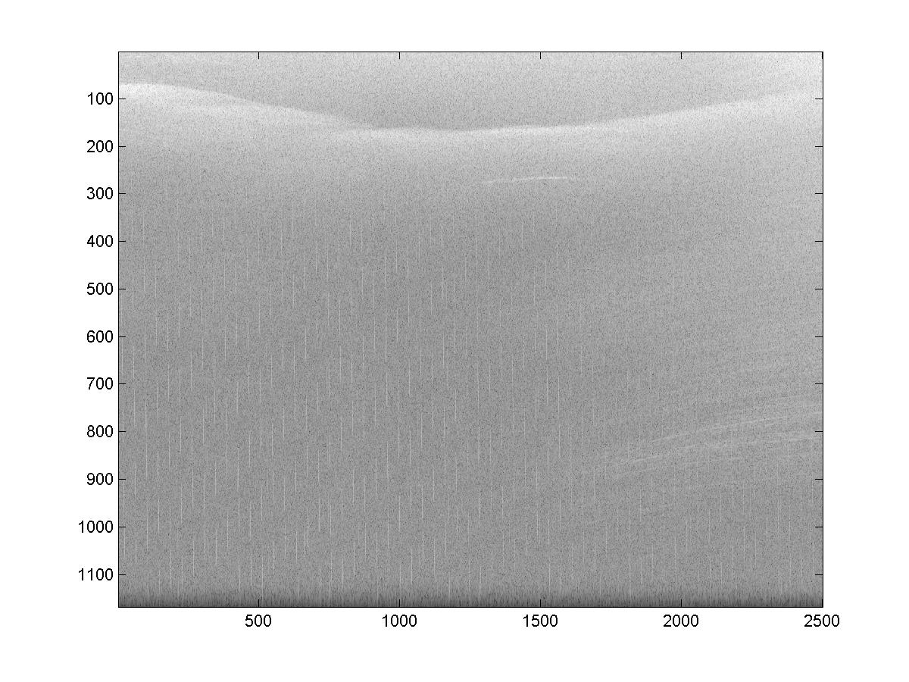

Figure 1. 150 MHz data low elevation near Rinks Glacier. Vertical scale is in units of 5 m in air.

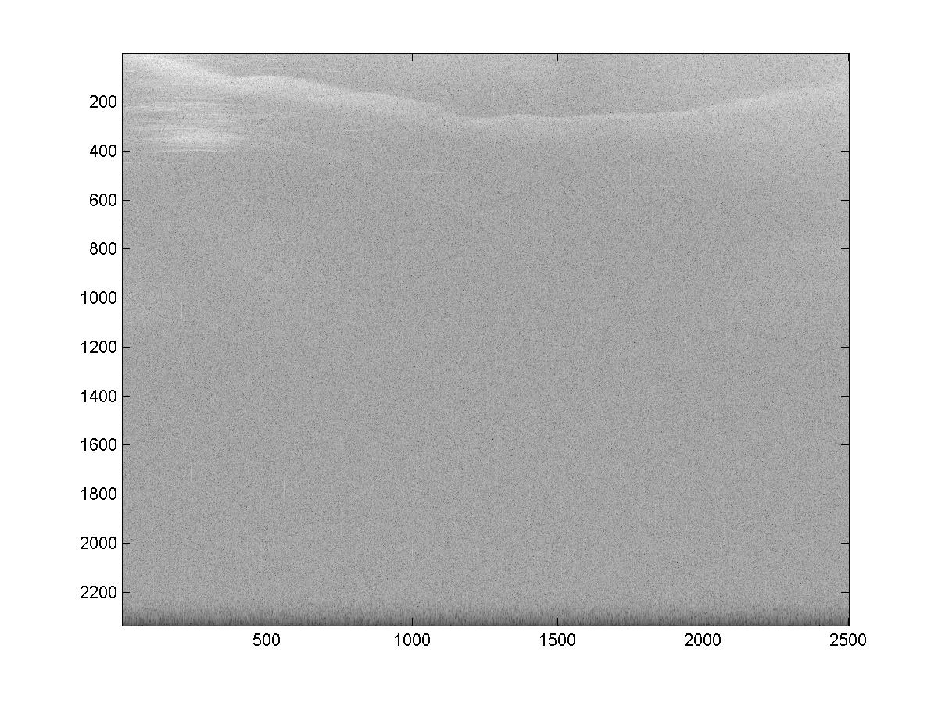
Figure 2. File 482 from Sept 15 450 MHz. Same areas as above. Vertical scale is in units of 2.5 m in air.

8.2 Ice Stream Case

The data best suited for early processing were those collected over the North East Ice Stream (Figures 3 and 4). It may be desirable to also select 150 MHz cards mode data from September 12 because of the increased signal level and length of the fading pattern associated with those data.

Sept 11 Hi 150 MHz 141-150
Sept 12 Lo 150 MHz 171-180
Sept 10 Low, 450 MHz cards 194-219

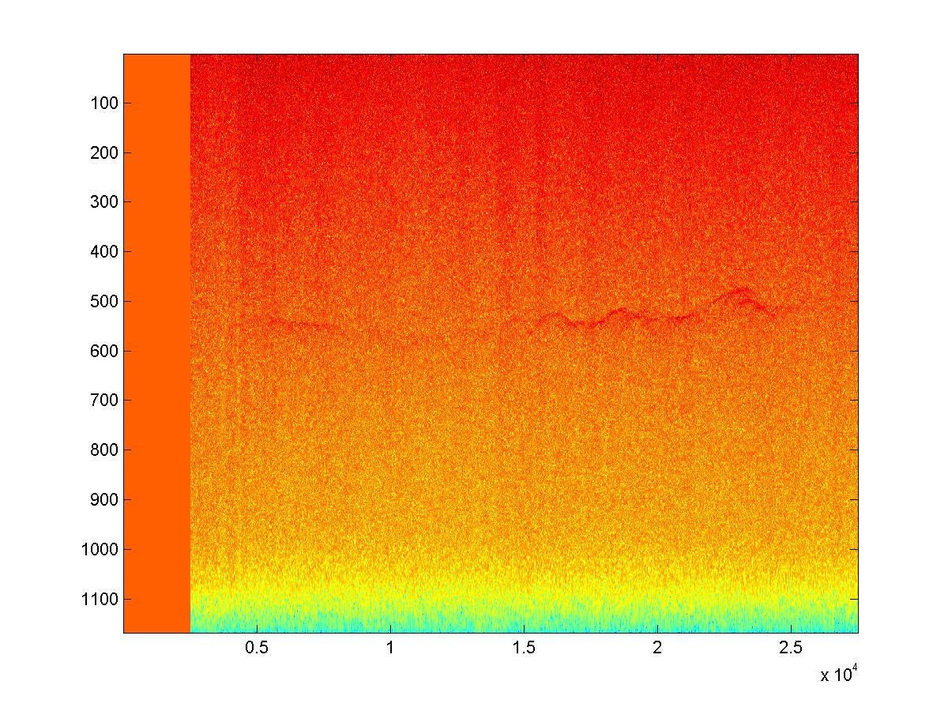

Figure 3. Ice Streams High Elevation 150 MHz

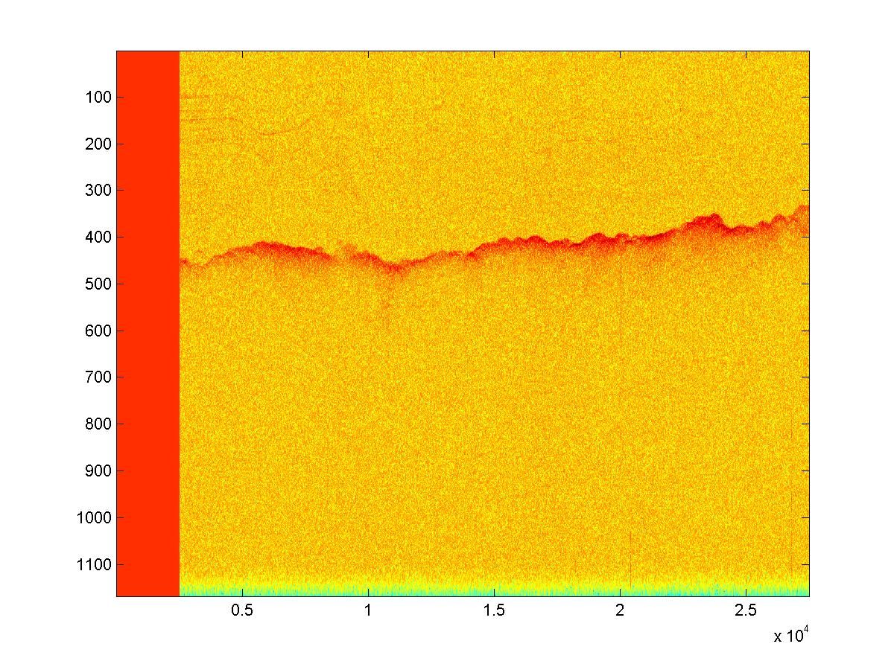

Figure 4. 150 MHz Low Elevation GISMO Mode

8.3 150 MHz clutter rejection case
We made special note of these high elevation 150 MHz GISMO data as suitable for testing clutter rejection (Figure 5). These files are located near NGRIP.

Sept 11, Files 260-269
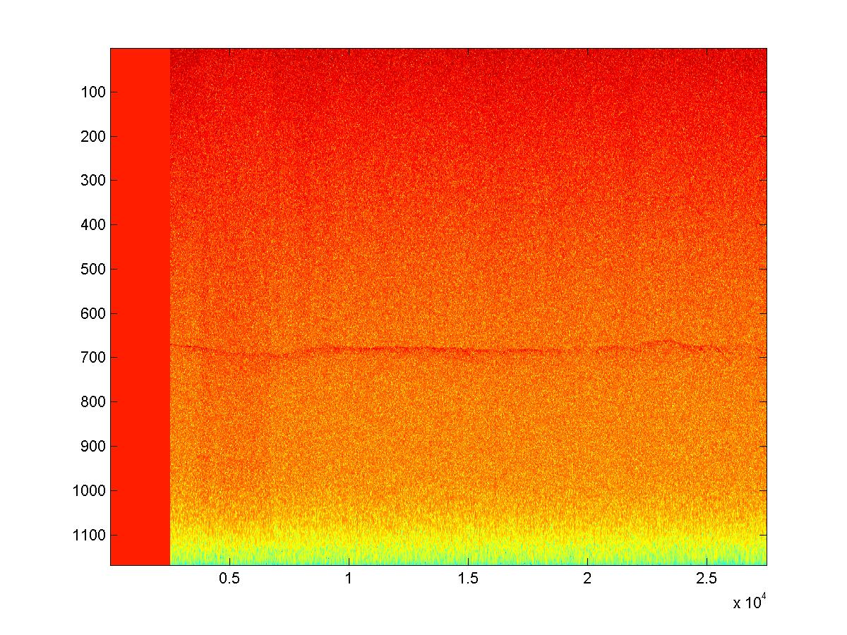

Figure 5. High elevation, 150 MHz GISMO data suitable for clutter rejection testing.

9.0 Near Term Science and Technical Objectives
We have two near term objectives in preparation for the January 2008 mid year review:

1.0 Use the Selected data sets identified above for clutter cancellation experiments. The procedure will be for Vexcel to process data to SLC images and distribute same to the team. JPL should plan to help with laser noise removal on some of the test frames, possibly by providing Vexcel with the appropriate noise removal algorithm. We will also require the calibration report from KU to help with phase and amplitude corrections.

2.0 Identify the best, low-elevation 150 and 450 MHz data to create DEMS. Good candidates are the depth sounder mode data collected in the vicinity of the ice streams. For the DEMS, the scientifically most interesting data are the ice stream locations and the 150 MHz low elevation data collected over Jacobshavn Glacier. Figure 6 shows the low altitude 150 MHz data collection up Jacobshavn Glacier. Reduced noise occurs after passing zones of heavy crevassing that develop downstream of this location on the faster portions of the ice stream.

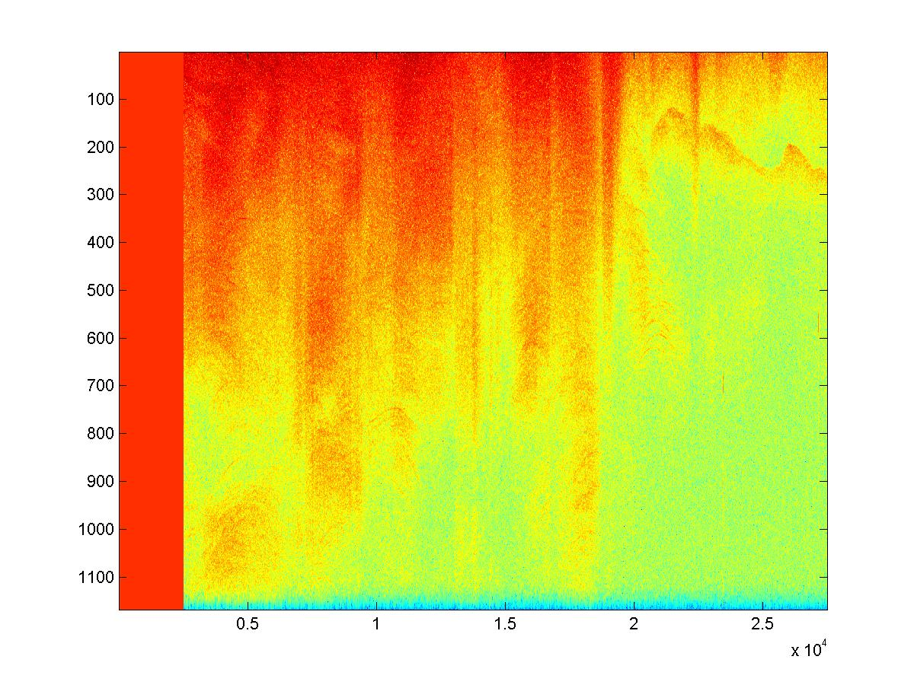
Figure 6. Low elevation 150 MHz data over Jacobshavn

10.0 References

Jezek, K., S. Gogineni, F. Rodriguez, A. Hoch and J. Sonntag. 2007. GISMO: Arctic ‚07 - Fall Deployment of the NASA P-3 to Greenland. Unpublished report submitted to ESTO

